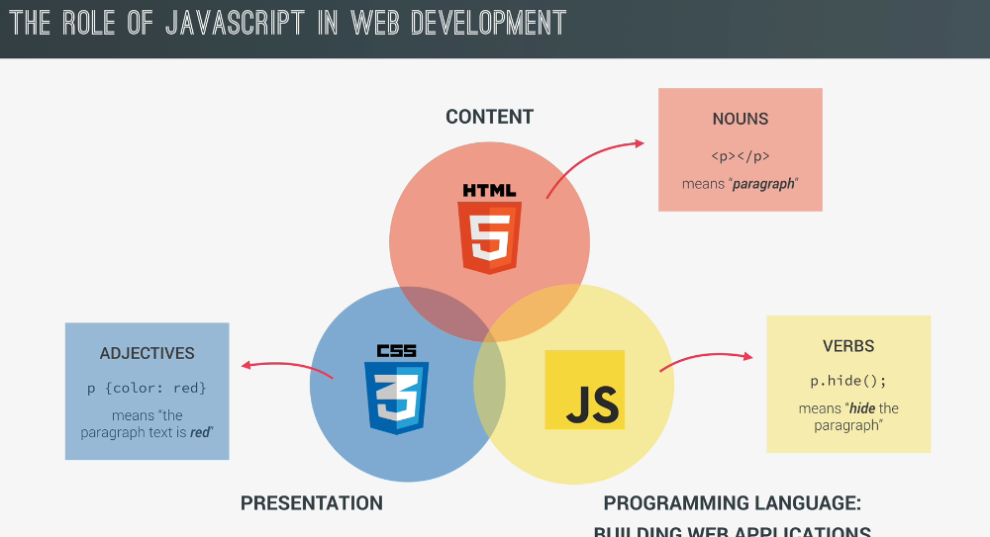

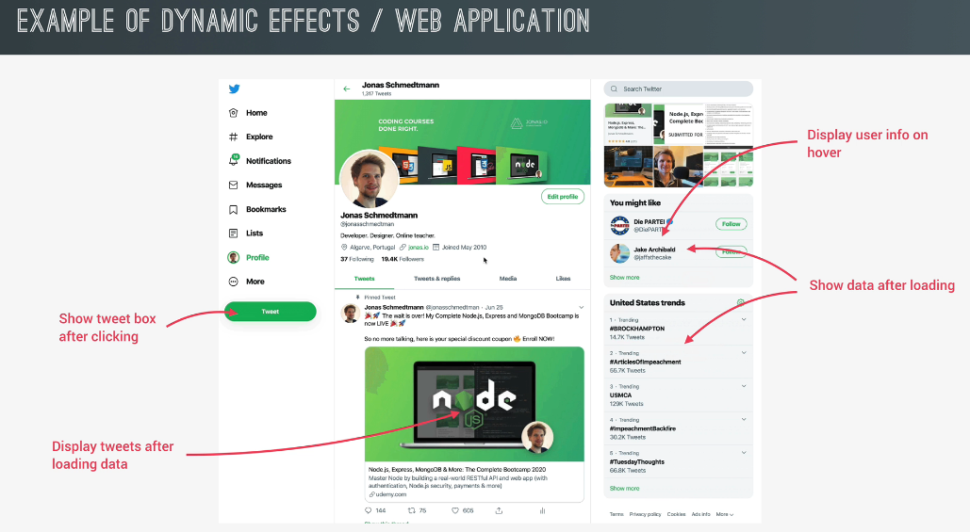

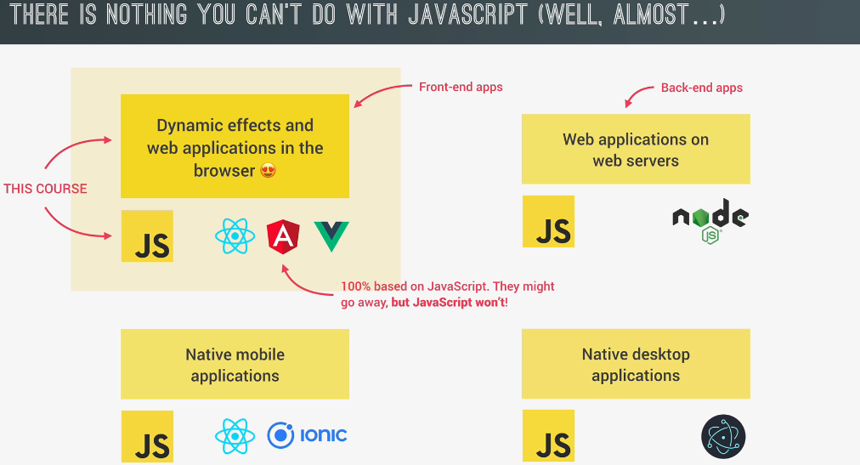

This is String Templates, ${} -> placeholder

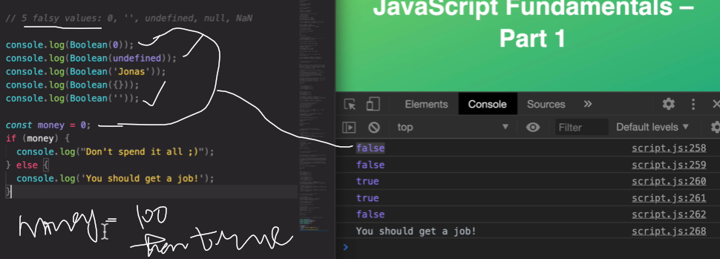

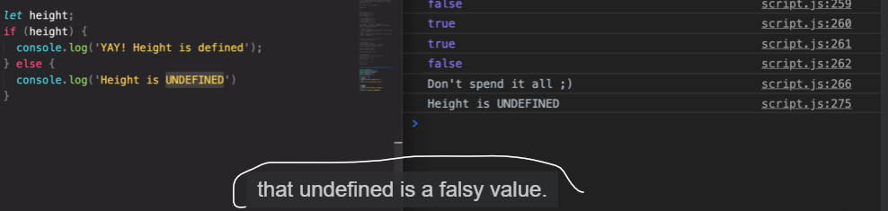

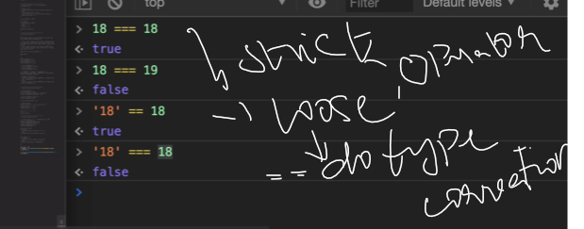

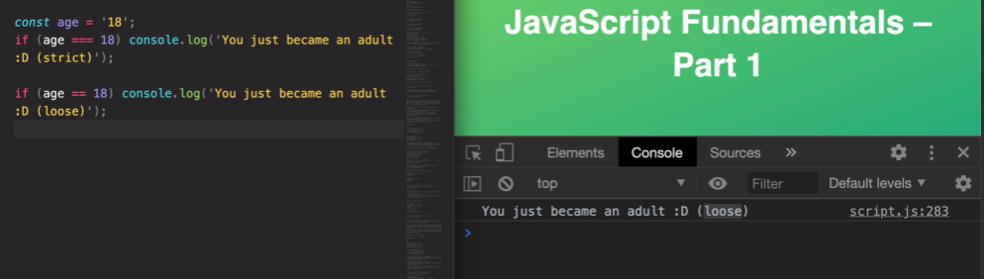

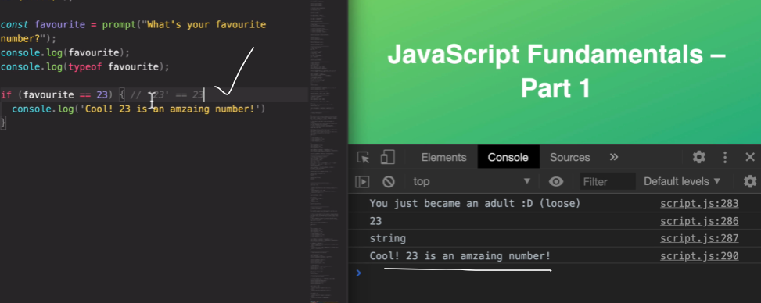

Strict version is mostly used in js

